**Object Oriented Programming LAB**



**Assignment 1st**

**Submitted to: Muhammad Ali-Khan**

**Submitted by: Nasratullah (FA18-BCS-401)**

**Submission Date: 14 March,2021.**

**Section: B**

Q1. Is it always necessary to implement data hiding and encapsulation in a program? Explain with the help of an example in case yes or no. [6]

**Answer:** It basically Defend on programmerif Programmer not want to change his data in future they can used Data hiding and Encapsulation concept in his program because It just provides a way to protect our data from the outside world. What it means is, let’s say if I made my instance variable public, then anyone can change its state. But if we make our instance variable private/protected then actually we are restricting outside entities from making changes to it.

So when we apply Data Hiding we must use Encapsulation Because **Data Hiding** is not possible without **Encapsulation.** You can't hide your data without putting it in some form of container. But yes **Encapsulation** is possible without hiding your data. Put all things public and you can see the affect.

Q2. Class Citizen holds two states i.e., “cnic” of type integer and “name” of type String, and a setter and getter method of type void and integer respectively that sets and returns the name state. An object of class Citizen is created in another class that holds main method. Explain what size is reserved for both classes in the memory. [7]

**Answer:**

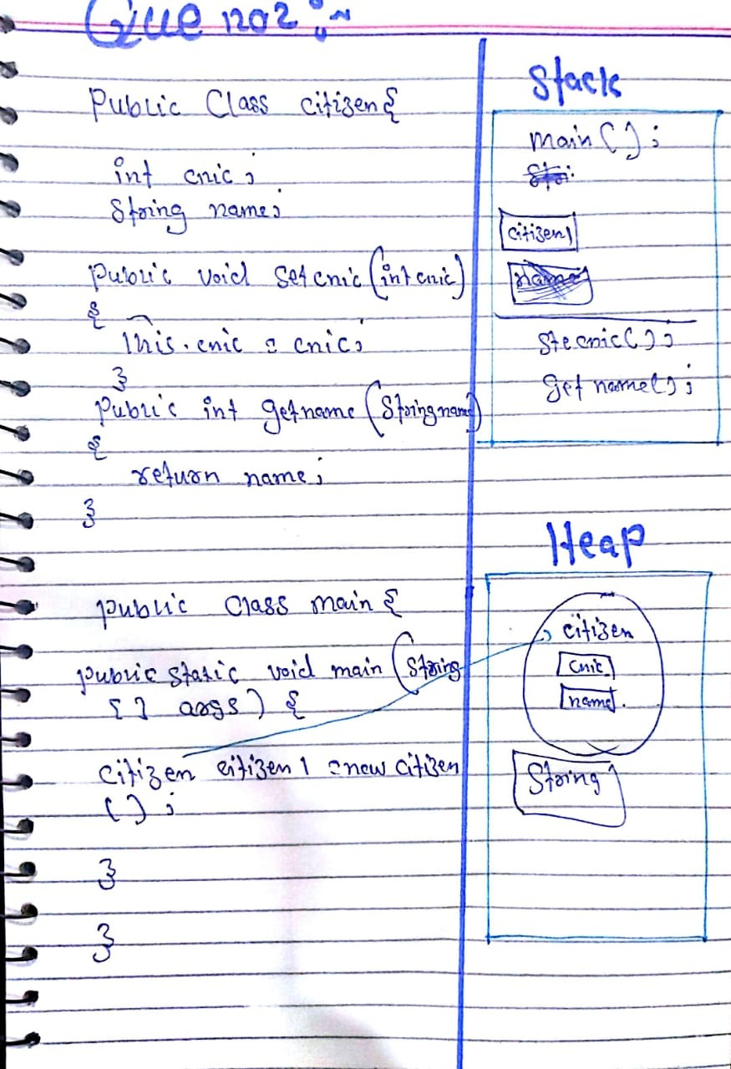

Q3. Why we need multiple constructors and multiple methods of the same name in a class? Provide an example to justify your answer. [6]

**Answer:**

Multiple methods with same name is called method-overloading. We need method-overloading in order to provide optional attributes feature for that method.

For example: because we don’t know how many attributes are available at the start in a student object, we provide multiple constructors with different number of attributes.

Student();

Student(id, firstName, lastName);

Sometimes there will be no phone number of some users. So in order to handle this scenario, we create a constructor without phone number parameter.

Student(id, firstName, lastName, phoneNumber);

Q4. There are four states in a class Pen. These states are “color” of type String, “ink” of color String, “manufacturer” of type String, and “inkThickness” of type double. How many setter and getter methods you need in this class and why? Which states can be made private and why? [6]

**Answer:** forsetter and getter there is must be state private but in this class we have no private instance variable so we don’t need to make setters and getters method in this class. so we have to make manufacturer and inkThickness private because we don’t want to change manufacturer name and inkthickness in future.